VISIT THE FERSON CREEK BOOK FAIR—*COMING SOON!*

**Book Fair Dates:**  November 16-23

**School Day Shopping Hours:** 8:30 am – 3:30 pm

**Special Evening Event:** Thursday, November 19,

from 5:30 pm – 7:30 pm

**Conference Day:** Monday, November 23, from 8 am – 6 pm

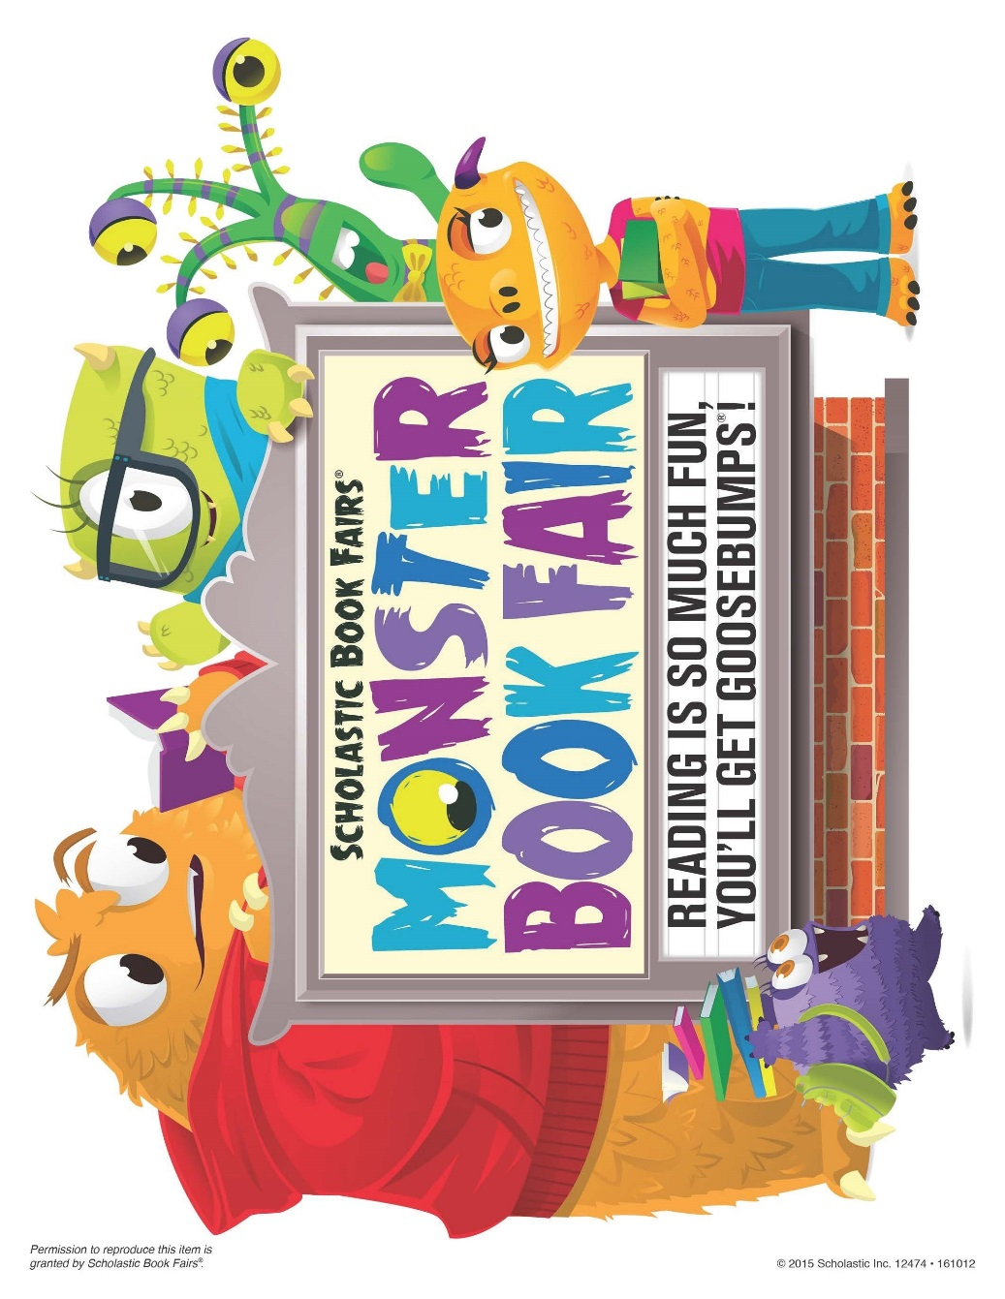

The LRC is getting ready for the **MONSTER BOOK FAIR**

And we can’t wait to see you there! A book flier will come home the week of November 9.