***Box Tops, Labels for Education & Pop Tabs***

Classroom Contest: February 8th to February 12th

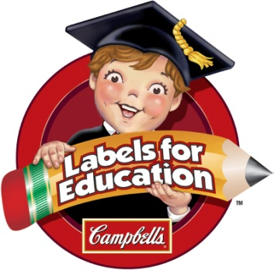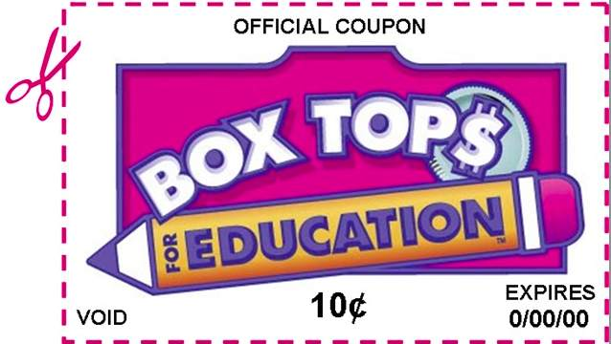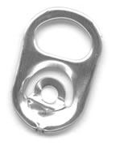

**Here is how you can HELP:**

* Box Tops and Labels for Education: They don’t need to be clipped perfectly - cut neatly or just rip ‘em off the packages. Double check the expiration date, expired Box Tops don’t count!!
* ***Please, please*** help the count!! Put them into a Ziploc bag or envelope, write the number of Box Tops and your child’s classroom code or teacher’s name clearly written on it to ensure proper credit. (For every 50 Box Tops, please start a new bag or envelope! Labels for Education in a separate bag/envelope, please.)
* Pop Tabs (including ANY variety of aluminum tabs) should be placed in a separate Ziploc bag or envelope with your child’s classroom code or teacher’s name clearly labeled.
* Collection bins are located in front lobby OR turn them into your teacher.

***Remember***: label the amount and your child’s class code (3JS, KKJ, etc.)

Collecting Box Tops and Labels of Education helps bring in funds to Ferson Creek, as well as buy art, athletic and academic supplies. Each Box Top is worth $ .10 for our school with opportunities for bonuses!

*The class that collects the most Box Tops and Labels for Education will win a party, AND the class that collects the most Aluminum Tabs will win a party! Winners will be announced in March. Thank you, good luck and happy collecting!!!*

**QUESTIONS? Want to help?**

*Box Tops & Labels for Education*:

Heather Mulcahy at [heathermulcahy@gmail.com](mailto:heathermulcahy@gmail.com)

or Tina Koral at [tinakoral@yahoo.com](mailto:tinakoral@yahoo.com).

*Pop Tabs*: Gretchen Martin at [glmartin10@aol.com](mailto:glmartin10@aol.com)