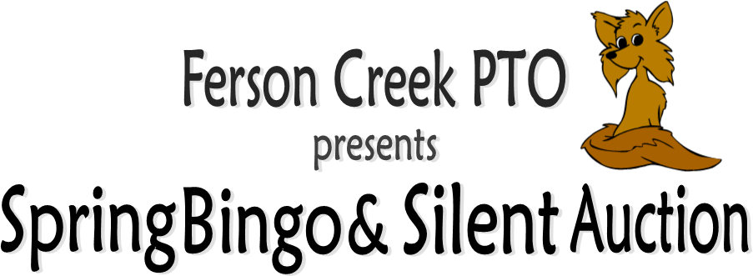

**Saturday, April 23rd 5:00-8:00PM**

ATTN: Ferson Families- we need your help!

Spring Bingo & Silent Auction are held in conjunction to help raise money benefiting all Ferson students. Our goal can be met with the generous support of our wonderful Ferson families by bidding on Silent Auction items, donating an item to be auctioned, buying table sponsorship or a combination. Monies raised go toward field trips, assemblies and the purchase of classroom technology.

We have been busy securing Silent Auction items for you to bid on. FEATURED ITEMS THUS FAR INCLUDE: Bears tickets, signed Blackhawk memorabilia (exclusively for Ferson), Disney Hopper Passes, Spa GC’s, jewelry, museum passes, kid party packages and more!

What can you donate? Below are a few suggestions:

* Sporting event tickets (Cubs, White Sox, Bears, Blackhawks, Bulls, Cougar tickets, Etc.)
* Theme Gift Basket (Toys, Movies, Cooking, Vacation, Etc.)
* Gift Card to your favorite restaurant, movie theater, sport complex or game place
* Vacation spot- like a time share or a hotel stay
* Do you own your own business? Could you donate a product or service? Your company will be advertised on the website as well as at the auction.

Business Sponsorship:

Sponsor a section at Auction, the Wheel of WOW, or the Kids Raffle and we’ll advertise business logos on event programs, signage at the event, distribute giveaways and handouts in the 125+ BINGO prize bags and more. Discuss options and ask event questions to Shannon at [shannonlnj4@gmail.com](mailto:shannonlnj4@gmail.com) cell (630) 247-6699 or Julie Baier at [shamshan@aol.com](mailto:shamshan@aol.com).

The PTO is a non-for-profit organization and your donation is tax deductible**. Fill out bottom portion and return it along with your auction donation to the Ferson Creek office by April 15, 2016.**

PTO Spring Bingo & Silent Auction Donation – DONATIONS NEEDED BY APRIL 15TH

(However, the sooner we receive your donation the sooner we can start advertising your business.)

Name: Email:

Company Name: Phone:

Item Donated & Value:

*Drop donations off in the office- you will be contacted to confirm receipt of donation. THANK YOU FOR YOUR SUPPORT!