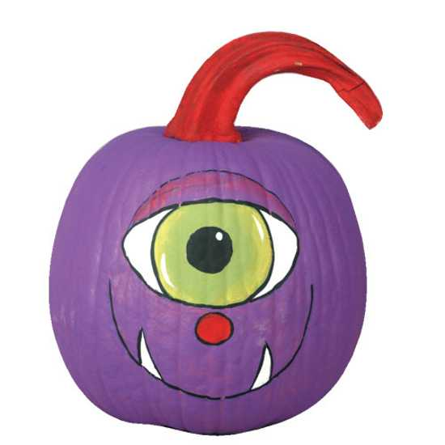

Decorated (Un-Cut) Pumpkin Contest October 24th to 28th

Judging October 28th, at 10:00 AM

Halloween is just around the corner, and we are planning for another great Pumpkin Decorating Contest! We are excited to see all of the beautifully decorated gourds adorning tables in the front hallway of Ferson Creek School.

You may bring your uncut, decorated pumpkin to school starting Monday, October 24th until the start of school on Friday, October 28th and put it on the table designated for your grade level. Please be sure to put your name on the bottom of your pumpkin and attach the contest entry form so the judges know which category you are entering. We have kept all the same great categories from last year plus added the category: “Scariest”!

Remember the “Family” category which is great to have moms, dads, siblings and other family members working together to create a special entry.

Judging will be Friday, October 28th, at 10:00 AM, and all pumpkins must be taken home by the end of the school day. If you don’t take your pumpkin home, it will be discarded.

**PUMPKIN DECORATING CONTEST 10/24-10/28**Bring your decorated (uncut) pumpkin with a completed entry form and place both on the designated table for your child’s grade in the front lobby. Tables will be

set-up Monday, October 24th thru Friday, October 28th.**Judging at each grade level will take place Friday, October 28th, at 10:00 AM**Pumpkins must be taken home Friday, October 28th by the end of the school day. Any unclaimed pumpkins will be discarded.**Each entry must have the included form filled out and left with the pumpkin**

**- - - - - - - - - - - - - - - - - - - - - - - - - - - - - - - - - - - - - - - - - - - - - - - - - - - - - - - - - - - - - -**

ENTRY FORM

SELECT THE CATEGORY IN WHICH YOUR PUMPKIN SHOULD BE JUDGED: TINIEST MOST COLORFUL ______FAMILY

SPORTS MOST CREATIVE SCHOOL SPIRIT FUNNIEST GLAMOUR GIRL _______SCARIEST ______CARTOON CHARACTER/SUPER HERO

NAME/FAMILY NAME: _______________________________________________________________

GRADE: ________________________________

\*\*\***PLEASE PUT YOUR NAME ON THE BOTTOM OF YOUR PUMPKIN \*\*\***